Hourly employees that work in the state of California must report their hours accurately to follow the labor laws of California.

**What do I need to do?**

* Hours must be reported on the actual day worked and all hours must be approved by your supervisor/time approver each pay period.
* You must get pre-approval from your supervisor to work more than your scheduled FTE.
* You are eligible for paid overtime for:
* All hours worked more than 40 each week (at a rate of time and a half).
* All hours worked more than 8 hours per day regardless of total hours worked per week (at a rate of time and a half).
* All hours worked more than 12 hours in a day regardless of total hours worked per week (at a rate of double time).
* Any hours worked after working 7 consecutive days in a work week, over 8 hours (at a rate of double time).

**How do I report hours worked hours for 8 hours a day or less?**

Log into [UAccess Employee](https://uaccess.arizona.edu/):

* UA Employee Main Homepage> Time> Enter Time

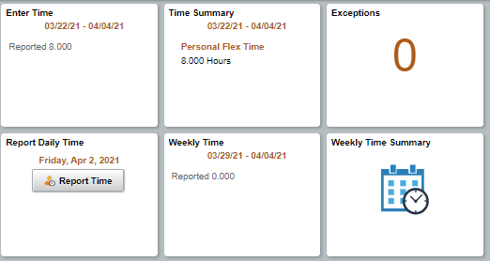

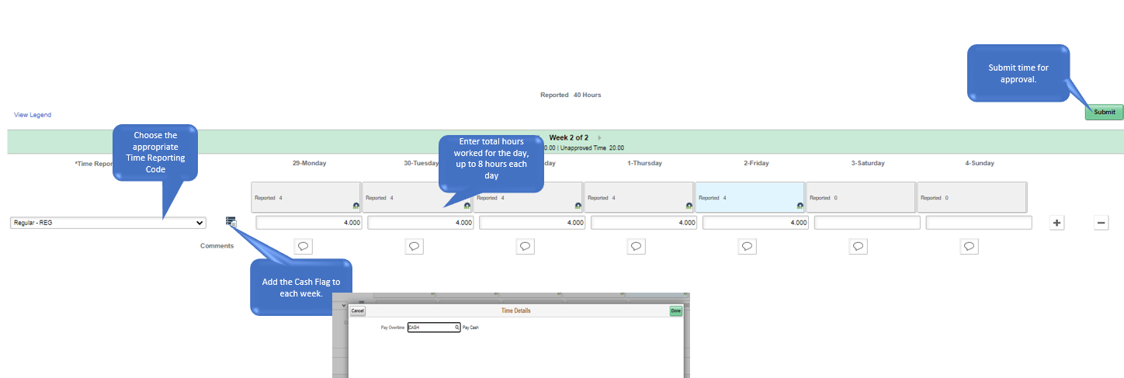

**How do I report hours worked over 8 hours in a day?**

Log into [UAccess Employee](https://uaccess.arizona.edu/):

* UA Employee Main Homepage> Time> Enter Time



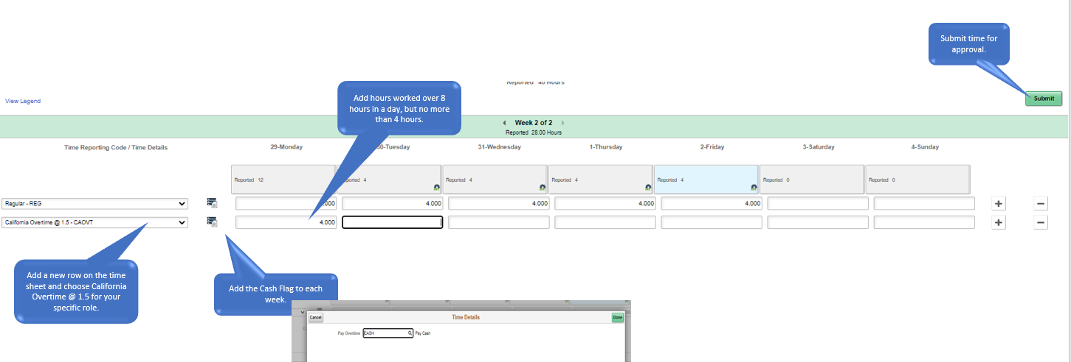

**How do I report hours worked over 12 hours in a day?**

Log into [UAccess Employee](https://uaccess.arizona.edu/):

* UA Employee Main Homepage> Time> Enter Time

 